**Artificial Intelligence Lab**

**Name** - N Aditya Sai

**Register Number**- RA1911030010075

**Topic**: Constraint Satisfaction Problem

**Experiment** – 4

**Aim:** To implement BFS (Breadth first search) and DFS (Depth first search) using python.

Breadth First Search:

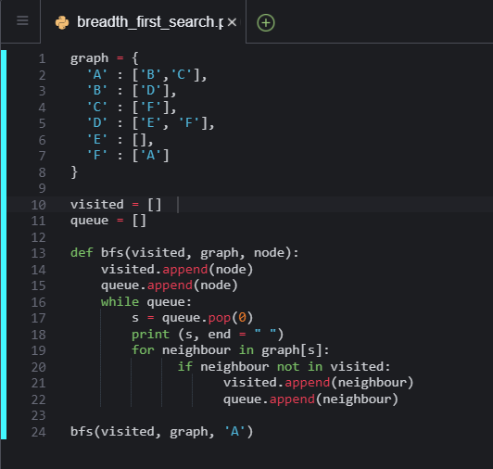

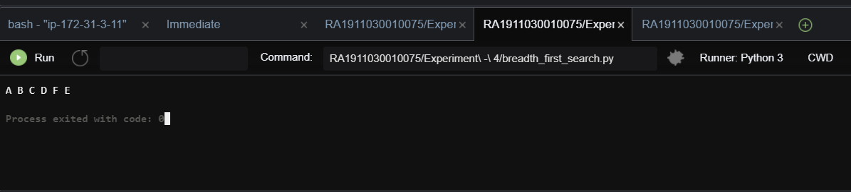

Depth First Search:

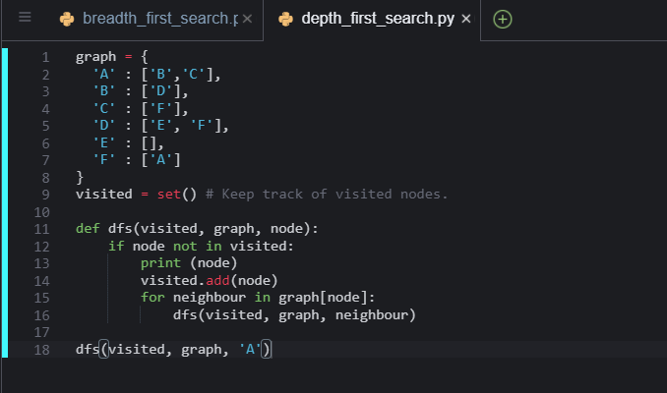

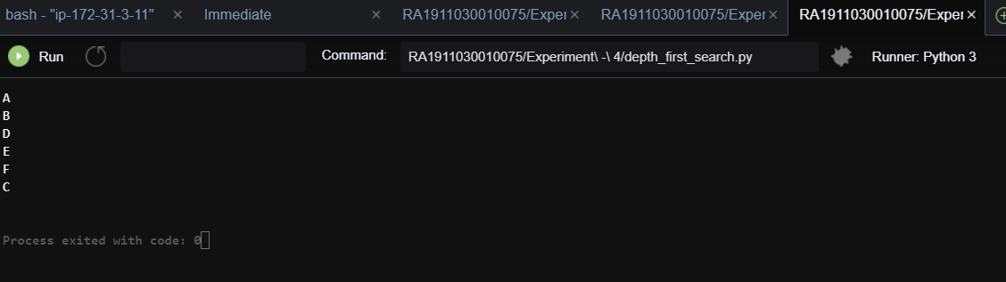

**Result:** BFS and DFS are successfully implemented using python in an AWS environment.